Convert XML File into Json File Format. You can consider below example XML, save it in the hdfs cluster and then to convert into Json File Format.

<property>

<name>fs.default.name</name>

<value>hdfs://localhost:9000</value>

</property>

<property>

<name>Namenode</name>

<value>hdfs:50070</value>

</property>

<property>

<name>Job Tracker</name>

<value>hdfs:50030</value>

</property>//Driver and mapper class

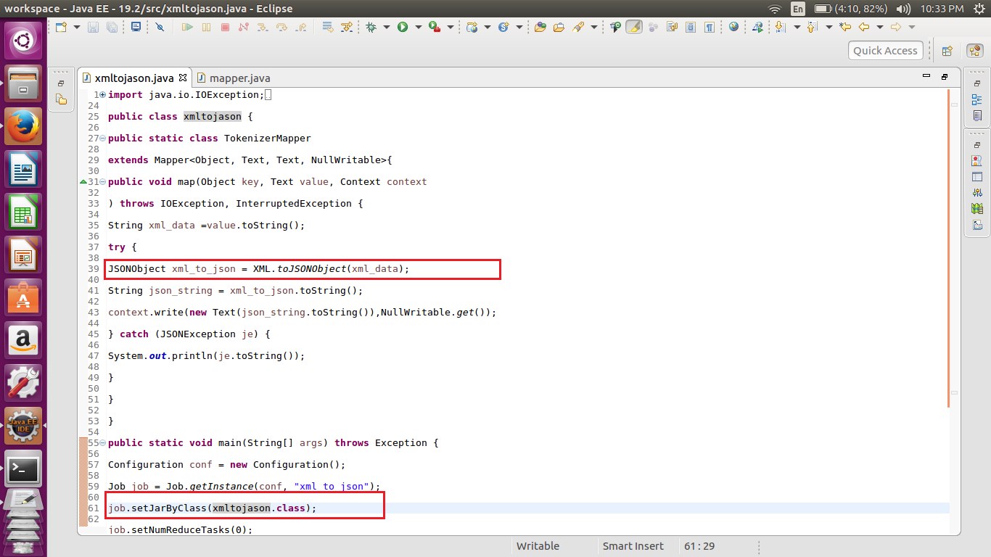

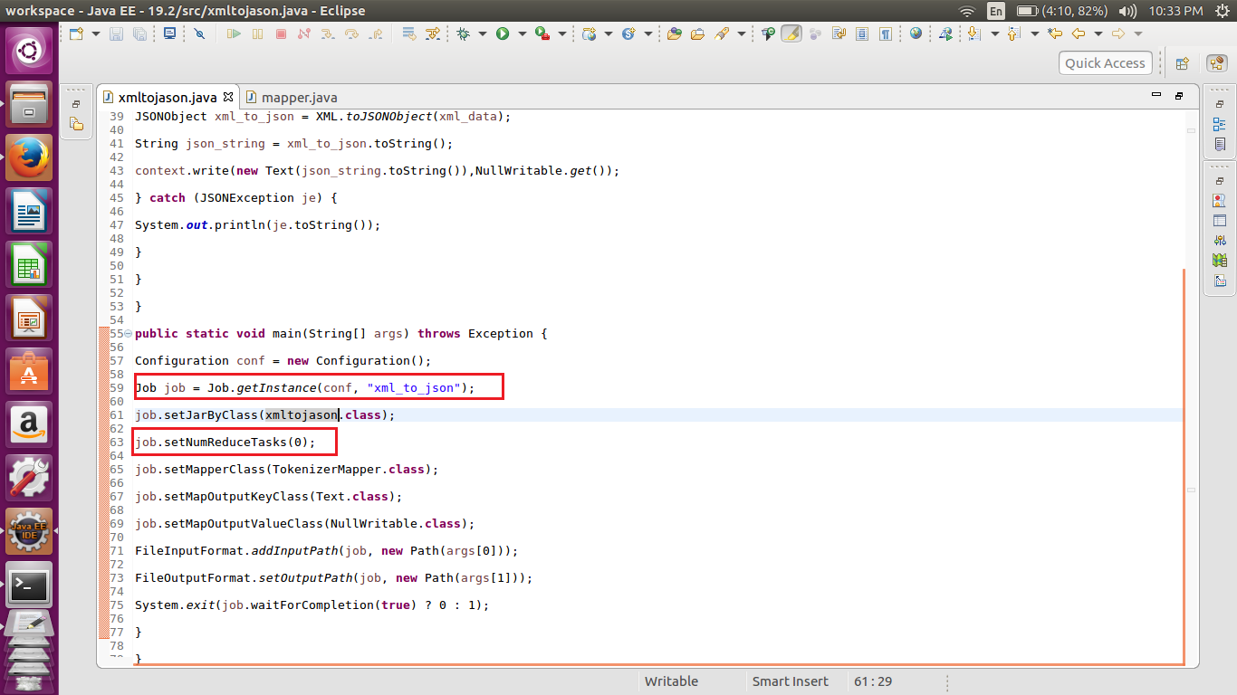

Here we have set the number of reduce task to zero. So map only job. In the mapper class we have created a JSON datatype to convert it into xml to JSON. Then convert it into the Jason file format using the command ‘XML.toJSONobject’ . Then we have converted to the String datatype using toString method. This String is passed to the context. Write().

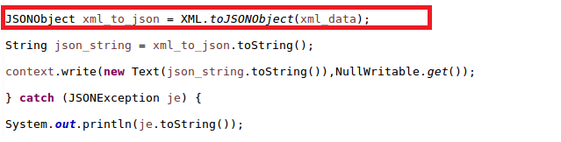

//input

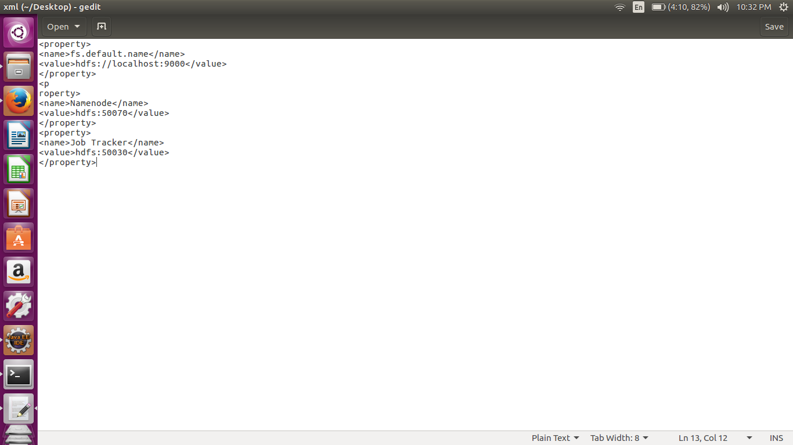

//implementation

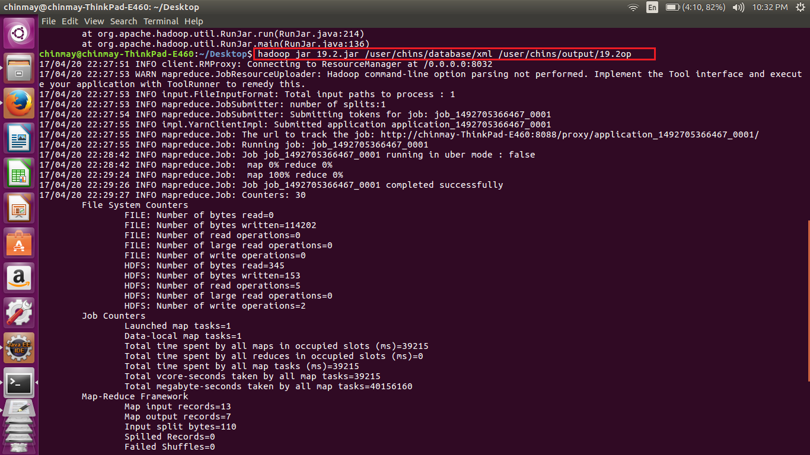

Here we are mentioning the input and the output path

//output

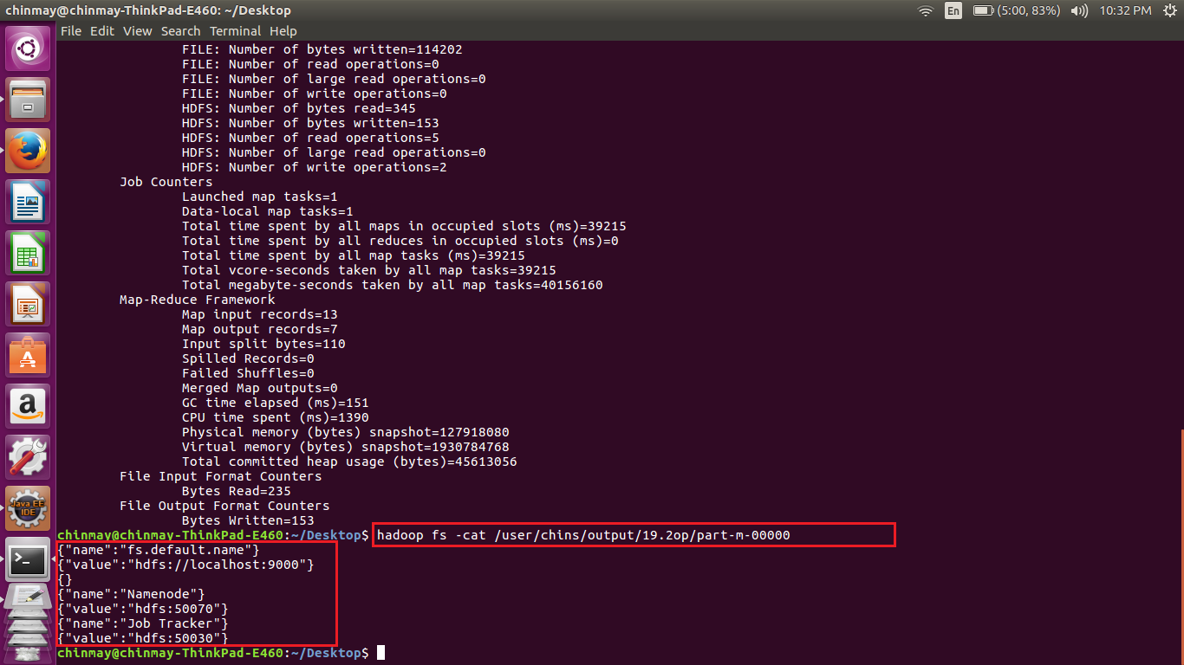

Here we can see that the give input is converted to JSON file format.

//